

informatic institue of technology

Computer science practice

4COSC008C

How computing can be used for the growth of film industry

How computing can be used for the growth of selected industry or a business

Module Leader’s Name-Ms. Sulochana Rupasinghe

S.M.K.C.Wedage

Uow Number-w1742101

IIT Number-2018368

**Table of content**

1. Introduction

2. Literature review

2.1 past and present of the film industry

2.2 dark side of film industry

3. Methodology

4. Discussion

5. Conclusion

**Abstract**

This report is about how computing helped to the film industry. Simply behind the scenes of a film. Directors, editors, producers spend months or even years to film a masterpiece. ICT ease their work. They face various barriers. Computing helped them. By using various computer aided cameras, AI cameras, slow motion cameras, AR cameras made the masterpiece looked easy. But there are many cutting-edge technologies behind those devices.

In chapter 2 I showed some of cutting edge software’s that is helped to the production of a movie while at chapter 4 I discuss some of the problems that is faced by movie editors and software developers. Ultimately I concluded what I see and how film industry could be grown in future.

**How computing can be used for the growth of film industry**

1. **Introduction**

**Change is the new constant**. Film industry is an industry that develops day by day. This industry relies on the trend and demand of the current world. Starting from the directing of the film to the releasing computing does a major role in many occasions.

There are various genre of movies, as example, action, thriller, mystery, romantic, comedy etc. For these genres they have unique aspects. So other than actors, graphical editing softwares plays a major role. One example is Computer Generated Imagery (CGI) is used to apply graphics to create special effects in movies. CGI was firstly invented in Ollie Barry. Graphical effects can be made by more expensive ways, but CGI is a way cheaper alternative. Because CGI uses computer software to create images. Movies like Avatar, Star Wars, The Lord of the Rings Trilogy*,* X-Men: The Last Stand*,* District 9*,* andKing Kong and in many super hero movies animations are widely used. Movies like avatar are entirely based on 3D graphics and animations.

In today’s world there are many software’s that aid on film making and to make films more interactive. For example, Windows Movie Maker is a software that allows user to create and edit videos.

Another example is Pencil. This is for animations and drawings. This is widely used in armature work because it has a user friendly interface. This works with the most common animation method which is supported with IOS, windows and linux operating systems.

In IOS and in Personal computers I movie and I dvd is used to edit and create videos ,not only that using this software’s special effects can be created. For special effects of movie making there are dedicated softwares. For examples Final cut studio, Advid , Frame forge 3D , Final draft, etc.

In these softwares there are pre made formats that can be apply by anyone. Various texture packages and graphic packages are available. Final draft is a software that used to write screen plays. In here there are pre made formats that is used by popular Big motion picture companies.

Ultimately, computing made movie making to a new dimension. Computer softwares helped to advance film industry and make artist to produce their work easily. Without this computing intelligence movie making would be impossible.

**2. Literature review**

**2.1 past and present of the film industry**

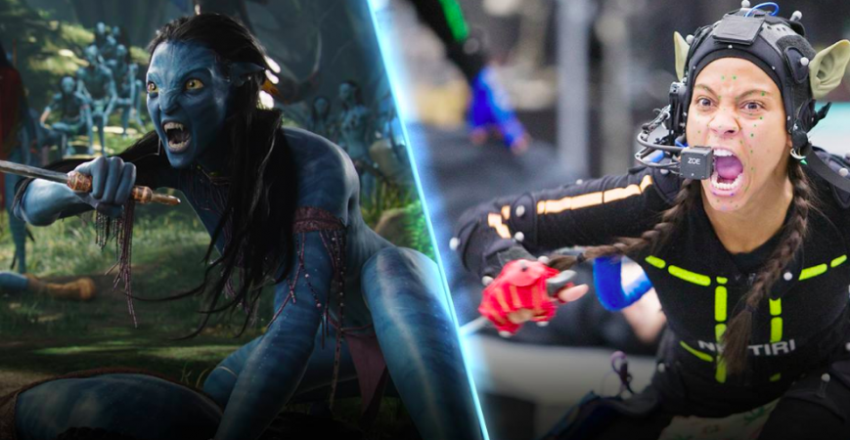When talking about how computing used in film industry, there is a one film that pop up in our mind. Undoubtly its Avatar by James Cameron in 2009.

**2.1.1 Transforming real world characters into animations-**

3D printing, virtual reality, depth sensors made this movie a masterpiece. The producers used a technique called the ‘image-based facial performance capture’, which required actors and actresses to put on special headgears called skull caps that were equipped with cameras. In this the facial expressions of actors were transmitted to the virtual characters from the high tech cameras . The movements caught on tape would be six times bigger, which created authenticity in the characters. By using such technology, the facial expressions of the characters can be made to change according to how the dialog was told.

Writing a screenplay for a movie in old days was a hateful task for screenwriters. Because it consumes way much time and more human energy. So it was a tiredfull task . But now there are various kinds of softwares and plugins. For example, Final draft is a software that ease the screenplay writing. Final draft has pre made formats that related to various reputed film making companies.

In past (days before computers) editors would spend hours even days to create special effects in movies. This is how the phrase "on the cutting room floor" came about. Modern editors use a computer to go through a movie frame by frame and scene by scene and can cut and move very precisely with the click of a mouse.

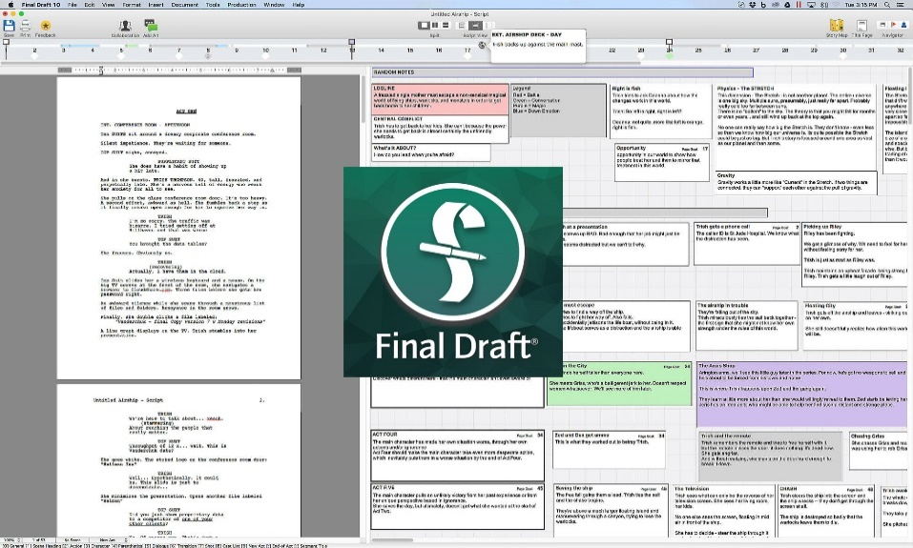

**2.1.2 Final Draft-**

**2.2** **Dark side of film industry**

And also like everything else this also have its own disadvantages as well. One major disadvantage of using computing in film industry is the issue regarding copyright and privacy as well as legal issues. Due to the advancement of technology one can conduct unauthorized access to filming details, its content, rights. Throughout the years’ film industry has suffered many cybercrimes and because of it many valuable movies were financial failures.

**3.Methodology**

In order to make this report I read a considerable amount of web articles and papers related to filming technology. Mainly I concerned about Hollywood movies. By some tutorials in internet, I studied how these applications support the filming technology. I also watched YouTube videos which are related. I read some newspapers which were wrote about Indian film industry (Bollywood). As India is a developing country I could sort some drawbacks of the industry which lead Bollywood look silly. I watched documentaries related to movie making.

After gathering some data, I discussed the facts with my friends. They helped me to find some examples regarding the data I fetched. After that I noted down some important points . With this sketch I mapped my report with the chapters and the content. I dropped so many unwanted facts. I used some images and labeled them in order to understand what I’m taking about.

1. **Discussion**

**1.**

**Problem**

In movie editing as I told above editors use computer softwares. But there is major problem. These applications only can be run with high end GPU’s .Simply with high end machines. Every person cannot afford this kind of high end machines. And these softwares are licensed softwares, which cost over than a single person can afford.

**Solution**

The software producers can produce softwares that can run in lower GPU machines with more servers involved. So by this the required performance of the software is served by the servers. By using lower powered engines the softwares could be run in any PCs.

**2.**

**Problem**

Another problem is about copyright issues. Simply can be known as piracy . Software developers create softwares with much dedication and much hard work. So developers give a value for their hard work. Most of movie editors purchase these softwares with license. But some tent to use copyright softwares with cracks used. So by this people use the softwares without the developer authorization. This is an easier way to work in the software without purchasing. This is called piracy. This is an illegal activity. Because of these developers don’t tend to create new software’s. But if it is caught developers can fine the people who used copyright softwares.

**Solution**

As far as concern, this might be the major problem. Earlier this was protected by patent law. But now it’s not enough. As known cracks are created for kind of softwares. So the editors which can’t afford that kind of money we should tent them to focus on open source softwares.

1. **Conclusion**

Further researches will be continued in secure the privacy data of owners of film industry. To make the film industry convenient as possible computing can be used. Which is more secure and ease ways. In future we can expect programs or software’s that help with film industry with minimum human involvement. By these directors and producers will ease their lives. And the film will get better and better as usual.

In future these devices will be portable by now they are not ease to carry here and there. Even though the electronic devices are small in future it will be more. We have to just be tuned. In future there will not be copywrite issues. Because software developers and editors more tend to use open source software’s.

We watch movies for entertainment, simply for fun. But there is a huge sacrifice at behind the scenes.

*Abstract*—Internet of things (IoT) means connecting things or electronic objects with each other or with their manufacturers sharing data and information. It can also be called a cloud which connects multiple devices and gathers information from those devices. Objects/things can be smart devices or electronic bio-implants in humans or animals.

Structure of internet mainly depend upon functionality rather than security and when we are talking about interconnection of these things, definitely security is also an issue because with the interconnection of smart systems private data is also at stake. There are many types of threats to IoT but in this paper we will only discuss Distributed Denial of Service (DDoS) attacks on Network Layer and Application Layer, which are capable of targeting and penetrating a victim from multiple sources seizing the resources of the network, and making them unavailable to the network’s users. In order to prevent from such an attack we need a way to detect and mitigate it. Over the time many people proposed multiple ways to stop it but there is no legitimate way to get rid of a DDoS attack on Internet of Things because of limited power of small devices.

**Keywords: -** Denial of Service, Distributed Denial of Service, Internet of Things.

IoT devices are ideal for DDoS botnets for a variety of reasons:

IOT means connecting electronic devices with each other to share data and information. Also can be called as cloud concept. In here IOT devices work as a system with many sub systems. Because of this, security is the main issue caused by this of interconnection. There are many types of threats caused by this interconnection.

But in here we will only discuss about DDOS and Botnet attacks. In here we are going to talk about attacks that are happening on Network layer and Application layer. Even though the technology grows up high and high, there is no legitimate way to stop these attacks because of limited power of small devices. There are many types of